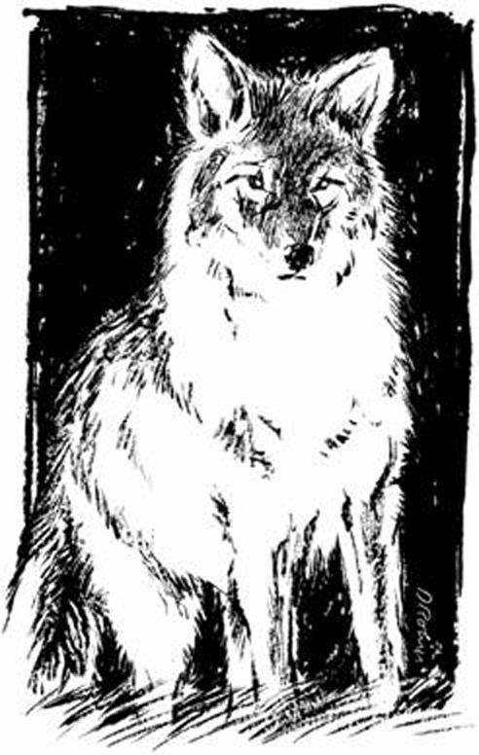
DONATION FORM

GW Community School 2017 Auction
An Online Silent Auction benefiting school technology and student enrichment.
February 21-March 2, 2017

Thank you for your donation! Your item will be sold via an online auction and will be viewed
by over 200 potential bidders. A picture of your item, along with a full description, credit and hyperlink to your website will be included.

Please complete this Donation Contract and submit it along with your auction item.

Donor Name:
(as you would like it to appear on the auction site and in print)
Contact:
Address:
Phone:
Email:
Website:
Item Donated:
Item Description*:
Restrictions: (if applicable)
Estimated $ Value:

*Please provide a complete, detailed description (include size if applicable). Include photographs and/or brochures if/when possible. Attach additional page for description if needed.

Note: Contract expires one year from auction date unless otherwise stated.

Donor Signature Date

Please return to: Deiadre Rauch, Auction Committee Chair, deiadrelrauch@aol.com; or leave at the GWCS Front Desk.
Thank you for supporting GWCS!
GW Community School, 9001 Braddock Rd, Suite 111, Springfield, Virginia 22151, 703-978-7208, www.gwcommunityschool.com

